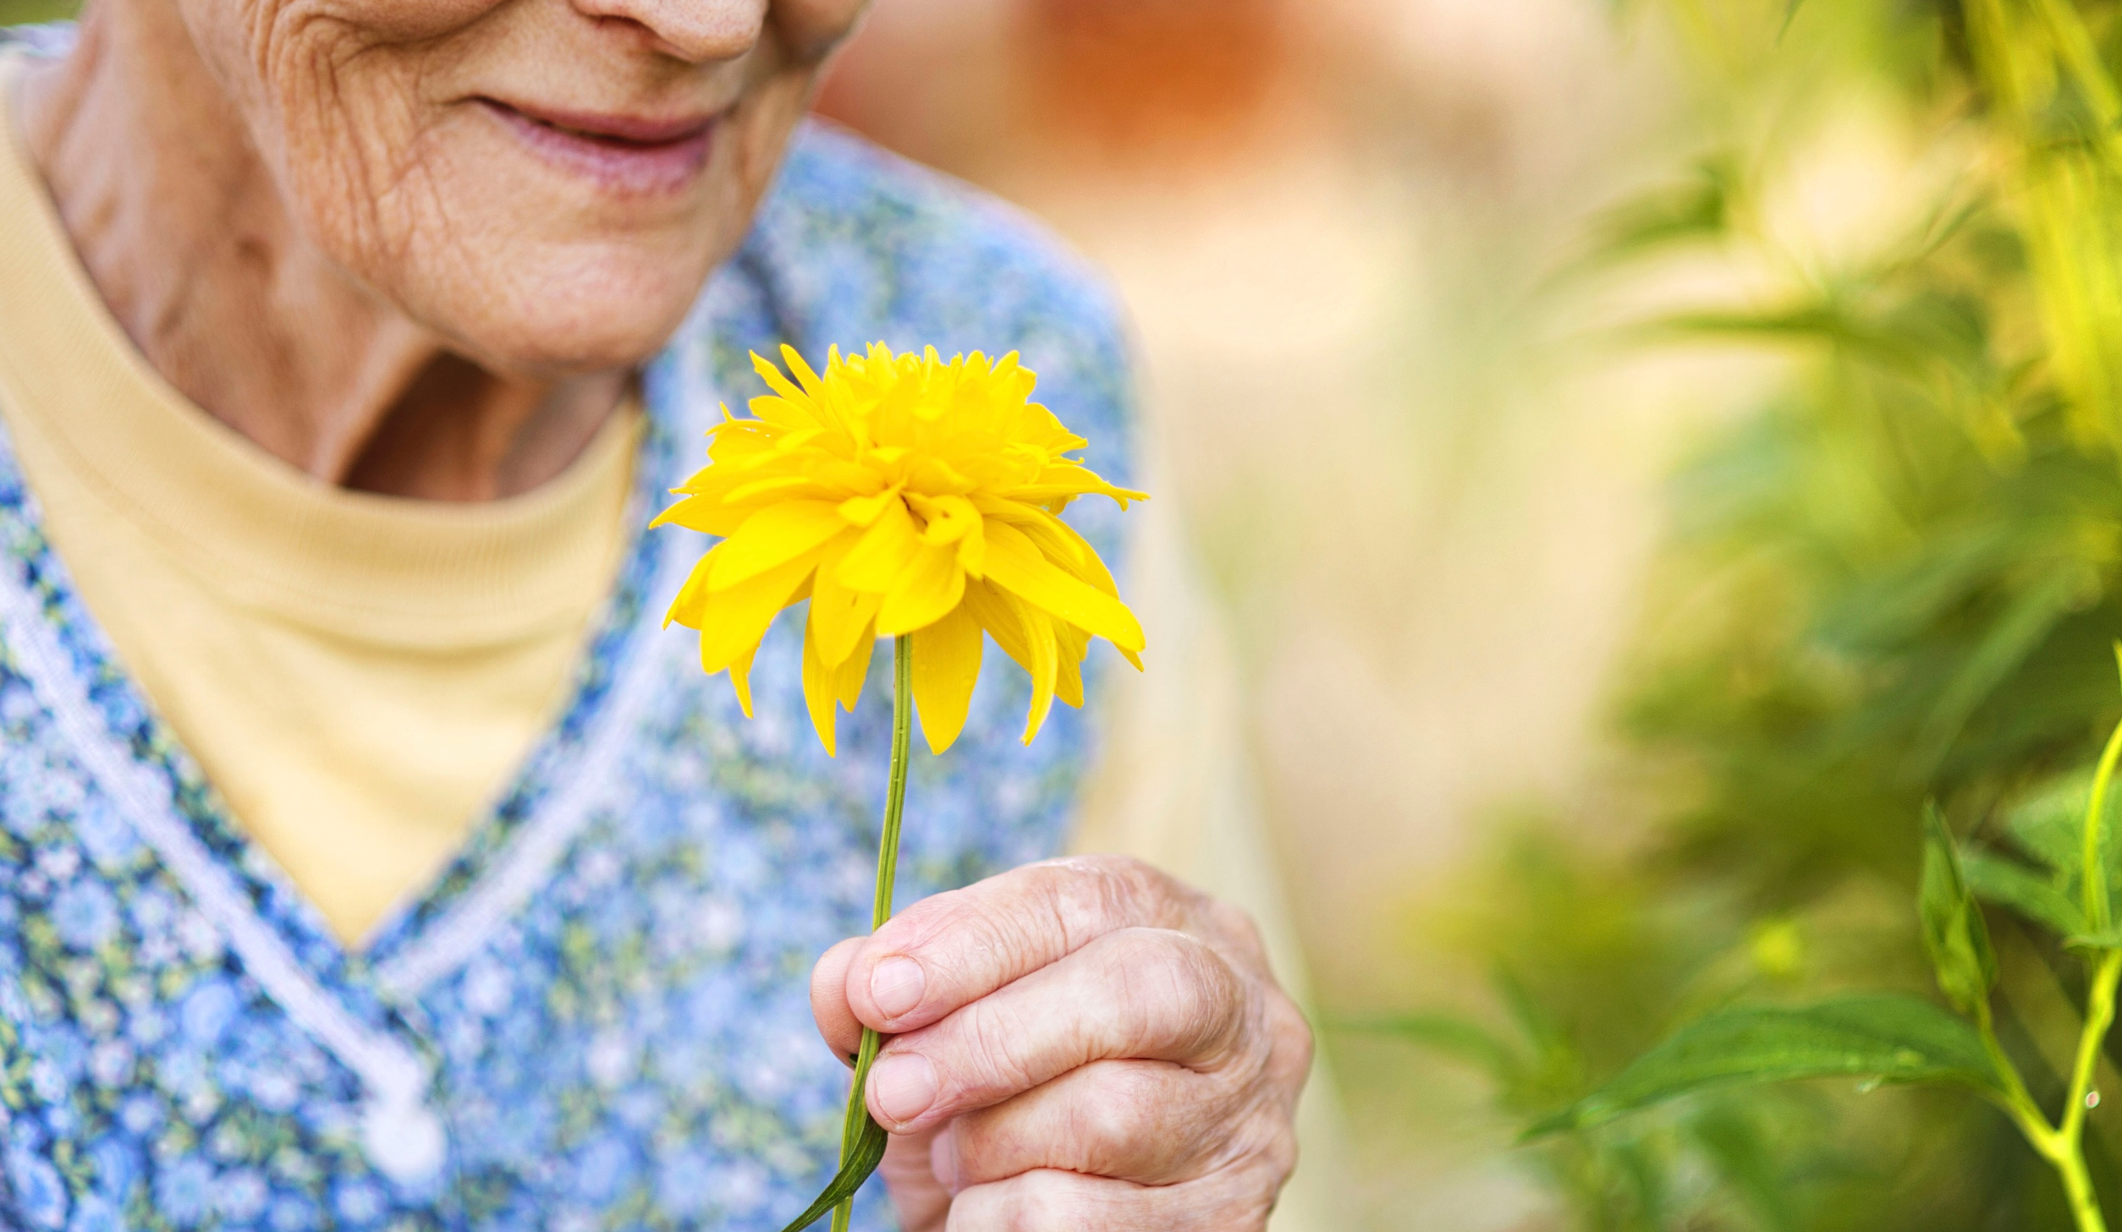
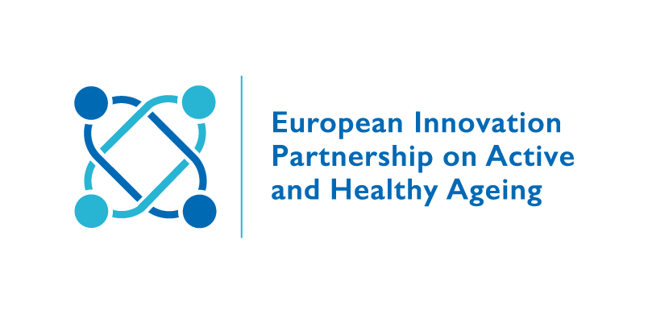
  - A3 Action Group on Lifespan Health Promotion &
  - Prevention of age related frailty and disease.
  - Thematic Round Table
Innovative approaches to healthy lifestyles: the case for FRAILTY & CAREGIVERS.
July 12th, 2018

PARTECIPANTS:
- FRAGILE - Frailty Research and Assessment-intervention in liGurian Interdisciplinary Laboratory for the Elderly, Serena Alvino/Daniele Musian (SI4LIFE scrl);

- Care for carers: an investigation on familycaregivers needs, tasks and experiences, Zavagli, Raccichini, Varani, Padoan, ANT Italia Foundation;

- Sunfrail in the Arena of older community-dwellers: the application of experimental protocol, Longobucco, Mantovani, Montali, Tagliaferri, Caminiti, Iezzi, Cacciapuoti, Moro, Barbolini, Maggio, (University of Parma and Emilia Romagna Region);

- MARIO: a companion robot that could prevent functional decline and frailty, Francesco Ricciardi, (ICT Innovation and research department, IRCCS Casa sollievo della sofferenza research hospital, san Giovanni Rotondo, Italy);

- Frailty as the future core business of public health: review of the piblic health activities of the European Innovation Partnership on Active and Healthy Ageing - A£ Action Group on Lifespan Health Promotion & Prevention of age related frailty and diseases, Liotta, Ussai, O'Caoimh, Illario, (Coordinator EIP);

- In Gaja, Andrea Giaretta, (Margherita Coop. Soc. ONLUS).

- “Healthy Brain” in Zagreb Retirement Homes – Health Promoting Project; Filip Đerke, Vanja Lazić, Nada Pjevač, Ino Protrka, Aleksandar Gluščević, Antonija Balenović, (Health Centre Zagreb - Croatia).

Proposed Moderator: Marcello Maggio – Paolo Padoan
Background & Logic of the discussion:
The ageing of the population is progressively increasing the incidence of chronic diseases that are responsible of much of the disability burden on social and health systems later in life. Early adoption of healthy lifestyles is needed to counteract poor health outcomes and improve quality of life. Primary prevention is fundamental, also secondary prevention is important for reducing chronic diseases and frailty of aging people.
QUESTIONS
Which innovative approaches are available for public health to ensure adequate and broad uptake by the population for adequate frailty and caregiver?
Which tools are available to support it?
Has effectiveness/impact been measured?
Which business models have been adopted?
What critical issues have there been? ...and how to overcome them?
How AG A3 could improve network and collaborations more than now?

PROPOSALS:____________________________________________________________________________________________________________________________________________________________________________________________________________________________________________________________________________________________________________________________________________________________ ________________________________________________________________________

CONCLUSIONS:__________________________________________________________________________________________________________________________________________________________________________________________________________________________________________________________________________________________________________________________________________________________ ________________________________________________________________________

